**What were the consequences of the Nakba for the Palestinians?**

**Lesson 7**

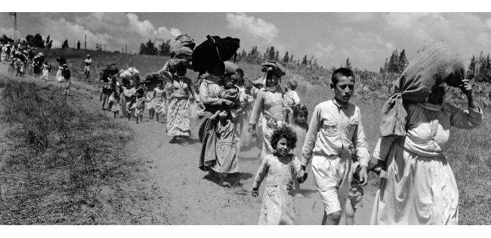

Palestinians fleeing during the Nakba

**By the end of this lesson, you should be able to:**

Describe the key events of 1947 and 1948 in Mandate Palestine

Explain what the Nakba was

Examine the consequences of 1947 and 1948, including the Nakba, for Palestinians and Jews

**Keywords**

Refugee

Ethnic cleansing

Right of Return

Nakba

UN Resolution 194

**Knowledge check!**

1)How did the following factors impact Britain’s decision to ask the UN for help with Mandate Palestine in February 1947?

-Concerns about a repeat of the 1936-1939 Arab Revolt

-World War Two

-The Holocaust

-Attacks by the Irgun and the Lehi in Mandate Palestine

2)What does it mean to be a refugee? Why do people become refugees?

**What did the UN say?**

As we saw in Lesson 6, in February 1947 Britain asked the UN for help. In May, the UN set up a Special Committee on Palestine (UNSCOP). Over the next few months, UNSCOP travelled around Mandate Palestine to investigate the situation. In September, they announced their recommendation that Mandate Palestine be partitioned into **separate Palestinian and Jewish states**. However, they recommended that Jerusalem and Bethlehem be under international control and accessible to both Palestinians and Jews, as Jerusalem and Bethlehem were significant to both sides. This is UN Resolution 181

**Debate on partition**

With a partner or in a small group, take it in turns to think about UN Resolution 181 from a Palestinian and a Jewish perspective. After a few minutes, switch and think about this from the **other perspective**. Make a note of the most interesting points raised in your discussion

**Reactions to partition**

The Palestinians were not happy with the prospect of partition - they would only have **45%** of their country left! Couldn’t European countries take in more Jewish refugees? On the other hand, the majority of Jews were happy with UN Resolution 181

**The vote**

The UN Partition Plan for Palestine was taken to a vote between nations, and on 29th November 1947, the UN Partition Plan was passed

As we saw last lesson, there was much support for an independent Jewish state at this time. The USA was in favour of partition, and many European countries wanted to stay allies with the USA after WW2. Supporters of partition included France, Canada, Australia, Brazil and South Africa. The USSR (Russia) voted for partition as it was keen to have the new Jewish state as an ally in the Middle East

Opponents included many of the surrounding Arab states such as Syria, Lebanon, Iraq, Iran, Egypt, India and Turkey

As a result of the vote, Britain would withdraw from Palestine and by August 1948 the country would be partitioned

**The Nakba**

The word Nakba in Arabic

 النكبة‎

Not long after the decision to partition Palestine, fighting broke out between Jews and Palestinians. What happened next is called the Nakba, Arabic for ‘catastrophe’

The Nakba involvedlarge-scale attacks aimed at expelling Palestinians from their towns and villages to build a future Jewish state, many aspects of which were part of Plan D or Plan Dalet, a Zionist plan to expel the Palestinians from Palestine. **530** villages and cities were destroyed and **15,000** Palestinians were killed in a series of mass atrocities, including more than **70** massacres. As a result of the Nakba, **750,000** Palestinians (half of the Palestinian population) were forced to leave their homes and became **refugees**

Palestinians also attacked Jewish communities during this period

**Case Study 1: Deir Yassin**

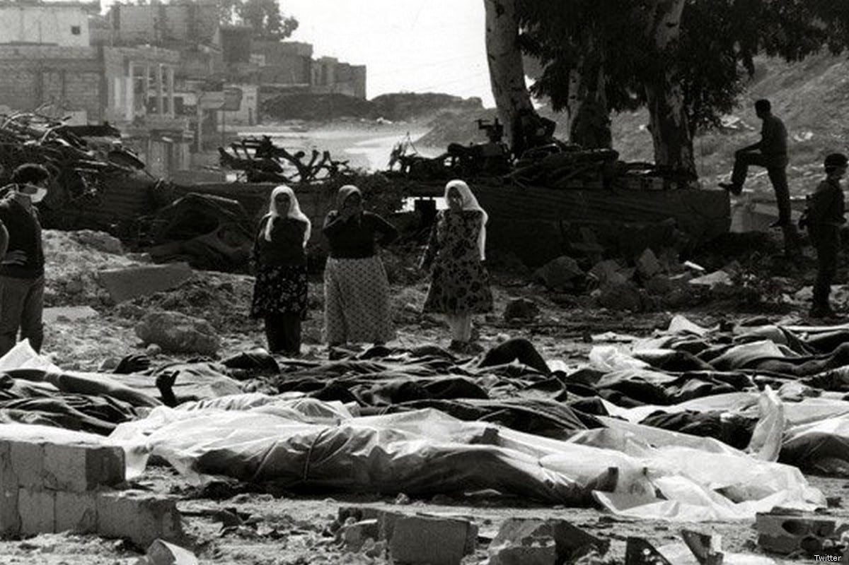

Deir Yassin was a village on the outskirts of Jerusalem, surrounded by olive, almond and fig trees. It was called Deir Yassin because there were the ruins of a monastery (‘*Deir’* in Arabic) and a mosque named after Sheikh *Yasin*

In 1943 and 1946, primary schools were established for boys and girls in the village, and in 1948 the population of the village was 750

The village had signed a “non-aggression” pact that it would not get involved with the fighting. However, on 9th April 1948, members of the Irgun and Lehi attacked the village. They **massacred between 100 and 250 people**, including women and children. There were reports of mutilations, rape and survivors being paraded through Jewish neighbourhoods before being executed

**Case Study 2: Tantura**

Tantura was a coastal village, not far from the city of Haifa. Most people in the village made their living from fishing and agriculture, including citrus, bananas, grain and olives. A boy’s primary school was established in 1889 and a girl’s primary school was established in the 1930s. In 1945 the population of Tantura was 1500

On the evening of 22nd May 1948, Zionist forces attacked the village. The villagers surrendered but **200 Palestinian men were still shot dead on the beach**. The other inhabitants of the village were **expelled.** At first they slept on the streets of a nearby village, but soon they were expelled from there also. Many of these Palestinian refugees and their children still live in refugee camps in Syria

**Case Study 3: Dawaymeh**

The village of Dawaymeh was in the Hebron Mountains. Agriculture was the main source of income and in 1937, a primary school opened. In the 1940s, the village had 10 butchers and 30-50 small shops

On 29th October 1948, Zionists entered the village in twenty armored cars. They **opened fire on the villagers, killing between 80 and 100 people**, including women and children. Eyewitness accounts report babies whose skulls were cracked open, women who were raped or burnt alive in houses, and men who were stabbed to death

**Massacres of the Nakba**

**The Palestinian refugee crisis**

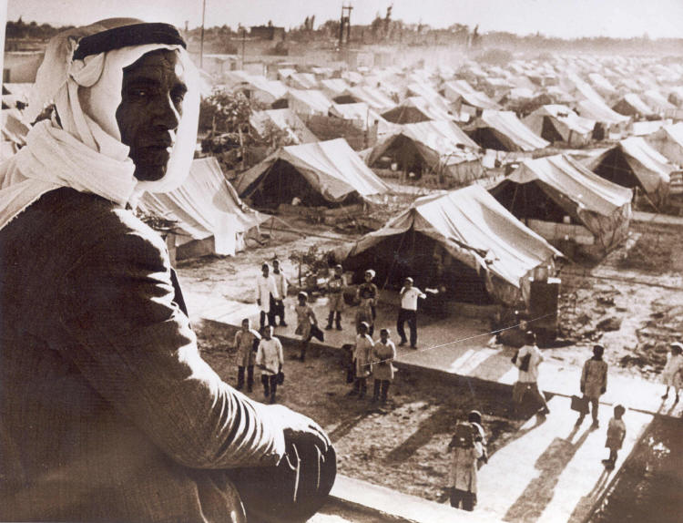

As a consequence of the Nakba, **750,000 Palestinians were now refugees.** Many of these now-homeless Palestinians sought safety in refugee camps in **Jordan, Lebanon and Syria** where **55 massive tented camps** were set up

In 1948, the UN adopted Resolution 194, which stated that Palestinian refugees should be able to return to their homes or be financially compensated. In December 1949, UNRWA (the United Nations Relief and Works Agency for Palestinian Refugees) was set up to help with these camps. To this day, Palestinians are still fighting for their Right of Return: a principle in **international law** which guarantees everyone’s right to return to their country

In 2021, there were an estimated 7 million Palestinian refugees

**Activity**

With a partner: put yourselves in the shoes of a Palestinian in 1948. Do you have a right to return to Palestine? Use UN Resolution 194 and the Right of Return to support your argument

**The creation of the state of Israel**

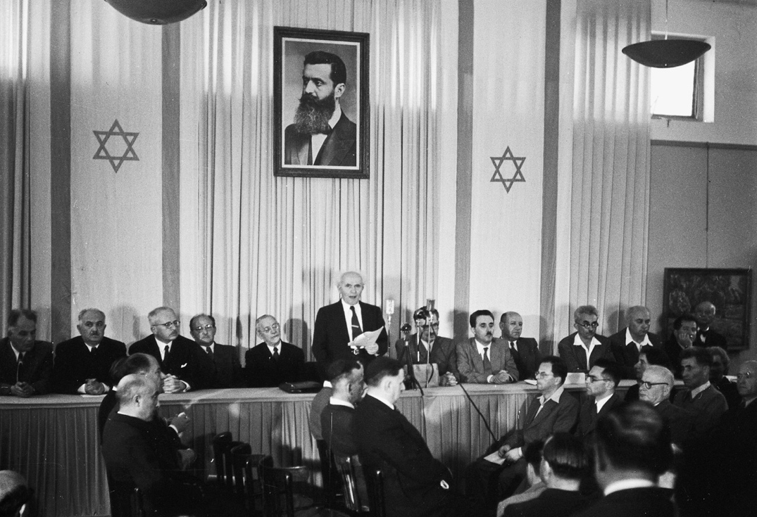

At 4pm on **14th May 1948**, David Ben-Gurion announced the establishment of the state of Israel. For many Jews, this was the “Year of Liberation”. As we have seen, Jews had suffered from antisemitic persecution for centuries, but now they had their own state

The USA and the USSR (Russia) immediately recognised the new state of Israel, but many of the surrounding Arab statesdenounced it, as they sympathised with the situation of the Palestinians. On **15th May 1948**, the **Arab-Israeli War began.** This involved much fighting for territory between the new state of Israel and the Arab countries of Egypt, Jordan, Syria, Iraq and Lebanon. Over 6000 Jews were killed in the fighting and many more Arabs (including Palestinians). By the end of the fighting, Israel had **78% of the land of Mandate Palestine**

**Question**

Was 1948 a year of catastrophe or liberation? Why?

**Law of Return**

In 1950 Israel established the ‘Law of Return’: this stated that **any Jew in the world** had the right to travel to Israel and become an Israeli citizen

What is the difference between the *Right of Return* and the *Law of Return*? How would this make you feel if you were Palestinian?

**Check your knowledge!**

What was the Nakba?

What were the consequence of the Nakba for the Palestinians?